GPV SHOULD GROW UP TO R$ 1.23 TRILLION IN 2021
15 September 2021
www.cnabrasil.org.br

The Gross Production Value (GPV) of Farming should reach R$ 1,23 trillion in 2021, as estimated by the Confederation of Agriculture and Livestock of Brazil (CNA). GPV is the gross turnover within rural establishments, considering agricultural and livestock productions, and the average prices received by producers all over the country. The projection was made with data until August for agricultural and livestock estimates, and also for prices.
In actual values, deflated from the IGP-DI of August, the 2021 GPV is expected to grow 10,3% compared to 2020 (R$ 1,11 trillion). Corn and soybeans are most responsible for the good results in this crop. Sugar cane is responsible for 10% of the agriculture result. Although domestic prices remained at high levels, production retreated that year. The southeast region, main producer in the country, suffered from drought near the harvest, hindering the development of crops, leading producers to deliver smaller quantities of cane for milling. According to the Brazilian Institute of Geography and Statistics (IBGE), sugar cane production in 2021 was 653.1 million tons, 3.7% lower than that produced in the previous crop.
The projection of R$ 1.23 trillion is similar to the value estimated in August. The harvests of major agricultural products are coming to an end, and there are few revisions in production estimates and smaller variations in average prices. In the agricultural sector, the GPV is expected to grow 11.0% compared to last year, reaching R$ 797.7 billion. According to the National Supply Company (Conab), the 2020/2021 grain crop will reach 252.3 million tons, 1.8% lower volume than the previous one. The drop in production will occur mainly due to lower productivity in second-crop crops due to prolonged drought and frosts.
The livestock GPV projection for 2021 is 9.1% higher than that achieved in 2020, reaching R$ 429.0 billion. Beef is still prominent, with average revenue reaching 16.0% higher than last year, and accounting for 52% of livestock GPV. Chicken meat is also worth highlighting, with a 13.4% increase in average revenue compared to the previous year. Average prices are 11.2% higher than in 2020. For pork, there was a contrary movement, with production practically stable but with a 12% drop in prices, making the average revenue 10.2% lower than in the previous year.
Forecast of Evolution for Farming GPV (R$ billion)
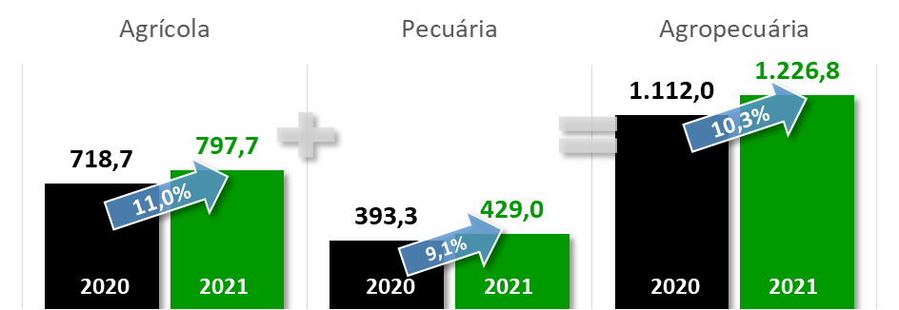
Production: DTec/CNA
Gross Value of Brazilian Farm Production - 2020 and 2021 – Actual Values (August 2021, IGP-DI)
Products | Production |  |  | Actual Average Prices |  |  | GPV (R$ million)
 | Unit | 2020 | 2021 | Un. | 2020 | 2021 | 2020 | 2021 | Δ%
Agriculture |  |  |  |  |  |  | 718,663 | 797,736 | 11,0%
Cotton (seed) ^{(1; 1)} | thousand t | 4.371 | 3.437 | kg | 0.95 | 1.49 | 4.131 | 5.116 | 23,8%
Cotton (lint) ^{(1; 1)} | thousand t | 3.002 | 2.358 | kg | 8.77 | 11.01 | 26.310 | 25.965 | -1,3%
Peanuts ^{(1; 1)} | thousand t | 558 | 597 | kg | 4.00 | 3.98 | 2.231 | 2.378 | 6,6%
Rice ^{(1; 5)} | thousand t | 11.183 | 11.747 | kg | 1.89 | 1.69 | 21.110 | 19.905 | -5,7%
Banana ^{(2; 5)} | thousand t | 6.718 | 7.035 | kg | 2.04 | 1.68 | 13.721 | 11.830 | -13,8%
Potatoes ^{(2; 6)} | thousand t | 3.680 | 3.869 | kg | 2.12 | 2.15 | 7.785 | 8.299 | 6,6%
Cocoa (almonds) ^{(2; 1)} | thousand t | 281 | 284 | 15 kg | 243.78 | 228.29 | 4.561 | 4.324 | -5,2%
Arabica coffee ^{(1; 6)} | thousand bags (60kg) | 48.767 | 31.355 | 60 kg | 713.04 | 835.90 | 34.773 | 26.210 | -24,6%
Robusta coffee ^{(1; 6)} | thousand bags (60kg) | 14.311 | 15.366 | 60 kg | 469.02 | 505.52 | 6.712 | 7.768 | 15,7%
Sugar cane ^{(2; 1)} | thousand t | 677,916 | 653,063 | t | 99.78 | 110.31 | 67.644 | 72.042 | 6,5%
Onions ^{(2; 6)} | thousand t | 1.719 | 1.719 | kg | 2.26 | 1.51 | 3.894 | 2.600 | -33,2%
Beans ^{(1; 5)} | thousand t | 3.223 | 2.856 | kg | 5.27 | 4.78 | 16.968 | 13.660 | -19,5%
Tobacco ^{(2; 8)} | thousand t | 696 | 716 | kg | 10.50 | 10.50 | 7.305 | 7.517 | 2,9%
Oranges ^{(2; 6)} | million boxes | 386 | 358 | box | 30.50 | 28.77 | 11.773 | 10.314 | -12,4%
Apples ^{(2; 6)} | thousand t | 1.192 | 1.250 | kg | 5.99 | 3.74 | 7.143 | 4.681 | -34,5%
Castor beans ^{(1; 1)} | thousand t | 43 | 27 | kg | 3.22 | 3.07 | 139 | 84 | -39,7%
Manioc ^{(2; 6)} | thousand t | 18.955 | 18.924 | t | 492.07 | 435.66 | 9.327 | 8.245 | -11,6%
Corn ^{(1; 6)} | thousand t | 102,586 | 85.749 | kg | 1.27 | 1.62 | 130,326 | 139,062 | 6,7%
Sisal ^{(2; 1)} | thousand t | 101 | 101 | kg | 4.79 | 4.66 | 482 | 470 | -2,6%
Soy ^{(1; 6)} | thousand t | 124,845 | 135,912 | kg | 2.51 | 2.93 | 313,406 | 398,600 | 27,2%
Tomatoes ^{(2; 6)} | thousand t | 39.566 | 37.696 | kg | 2.66 | 2.05 | 10.524 | 7.723 | -26,6%
Wheat ^{(1; 6)} | thousand t | 6.235 | 8.156 | kg | 1.55 | 1.61 | 9.653 | 13.132 | 36,0%
Grapes ^{(2; 6)} | thousand t | 1.416 | 1.688 | kg | 6.17 | 4.63 | 8.743 | 7.813 | -10,6%
Livestock |  |  |  |  |  |  | 393,290 | 429,028 | 9,1%
Beef ^{(3; 6)} | thousand t | 9.864 | 10.400 | 15 kg | 294.86 | 324.39 | 193,899 | 224,910 | 16,0%
Chicken ^{(4; 7)} | thousand t | 13.800 | 14.076 | kg | 4.79 | 5.32 | 66.086 | 74.927 | 13,4%
Milk ^{(3; 6)} | million litres | 35.148 | 35.499 | litre | 2.24 | 2.19 | 78.856 | 77.908 | -1,2%
Eggs ^{(4; 6)} | thousand boxes with 30 dozen | 148,702 | 156,793 | dozen | 4.60 | 4.43 | 20.526 | 20.835 | 1,5%
Swine ^{(4; 6)} | thousand t | 4.270 | 4.350 | 15 kg | 119.17 | 104.99 | 33.922 | 30.448 | -10,2%
Farming |  |  |  |  |  |  | 1.111.953 | 1.226.764 | 10,3%
Production: DTec/CNA
-3,5%
+5,5%
Sources: (Production and Prices)
(1) CONAB; (2) IBGE; (3) CNA; (4) ABPA; (5) Agrolink; (6) Cepea; (7) Jox Assessoria; (8) Afubra;

